Exercise Handouts for “Project Management using S|A“

This document contains the participant instructions for exercises (where required) in the “Project Management using S|A” course. The entire document should be printed out prior to the course, and the handouts for each individual exercise should be given to participants before each exercise (as opposed to giving them instructions for all exercises at once).

Exercise handouts exist for the following exercises:
- Exercise 1 – Waterfall versus Agile configuration of S|A
- Exercise 2 – Defining scope
- Exercise 3 – Estimating a project
- Exercise 4 – Setting up a project using ResultSpace
- Exercise 5 – Kicking off and closing an iteration role-play scenarios
- Exercise 6 – Monitoring progress
- Day 3 case study background and instructions

Exercise 1: Agile versus Waterfall Configuration

Read this handout carefully before you start the activity.

Background:
Sapient|Approach (S|A) defines the model that is used to deliver projects. S|A is based on Agile principles, however S|A can also be configured to cater for projects where our client is requiring a Waterfall model (i.e. Design Phase with a list of specific deliverables to sign off, Implementation Phase which is the phase where coding starts, Integration and Testing Phase etc).

Instructions:
For this exercise, you will be broken into 2 teams. Each team will need large Post-its and white board markers and each team will have their own plotted version of the HLP.
In your team, follow these instructions:
- Using the large post-its and white board markers, write each story clearly using capital letters on a post-it from your team’s list of stories.
- Create the Release Plan by sticking each story on the HLP within the appropriate release and iteration
- Once each team has the Release Plan in place, we will compare the Agile version against the Waterfall version, and highlight differences and similarities

Agile Team Stories
Set up workstations and infrastructure
Define list of use cases
Create and document site map
Document editorial workflow use cases (high risk)
Document logical architecture
Document the test strategy
Document high level physical data model
Design home page (Creative design)
Design core templates and modules (Article, Image, Table module) (Creative design)
User is able to view the home page
User is able to view and edit article template
User is able to view and edit article, image and table modules
User is able to view video
User is able to view and edit picture gallery
User is able to search
User is able to view “Articles I have read” (personalisation)

Waterfall Team Stories
Set up workstations and infrastructure
Define list of use cases
Create and document site map
Document all use cases
Document logical and physical architecture
Document the test strategy
Document physical data model
Design home page
Design all templates and modules (Article, Image, Table module)
User is able to view the home page
User is able to view and edit article template
User is able to view and edit article, image and table modules
User is able to view video
User is able to view and edit picture gallery
User is able to search
User is able to view “Articles I have read” (personalization)

Exercise 2: Defining Scope

Read this handout carefully before you start the activity.

Background:
The Star Alliance, launched on May 14, 1997, is the largest and most awarded airline alliance in the world, with the following points of cooperation among its partner airlines:
- Frequent flyer program integration allows airline miles to be earned and redeemed on all members of the Alliance at the same level
- Premium customers of the alliance have access to all members' airport lounges.
- Flight schedules are coordinated to permit almost seamless travel which may include several different carriers within the alliance, on a single ticket
- Special fares for round-the-world and similar travel on alliance members offer discounts over booking individual itineraries
- Customer service processes are harmonized in an effort to promote a consistent experience
- Cooperation in development of a common information technology platform
Star Alliance selected Sapient to help them implement short term changes to the StarAlliance.com site, to enable them to take the lead over competing alliances, set the site up for future enhancements and implement a content management system. Star Alliance asked Sapient to deliver a redesign of the current site and implement the content management system based on a set of requirements and priorities listed by Star Alliance Services.
Star Alliance Services started the StarAlliance.com redesign initiative to achieve the following business objectives:
- Provide a compelling user experience corresponding to Star Alliance brand promise
- Regain the lead in the web offering over competing alliances SkyTeam and oneworld
- Adjust and extend the StarAlliance.com service offering to match the target user segment(s) and provide alliance-specific services
- Adopt recent trends in airline industry eServices, targeting the segment of the high value international traveller and complementing the services provided by member carriers
- Prepare StarAlliance.com for further enhancements and value-added features, leading to the vision of a Star Alliance travel portal (to be defined in more detail)
- Implement a content management system that provided an intuitive content management experience for the editorial process
As part of the Fusion phase, Sapient committed to delivering a plan and price for the rest of the engagement.
The Star Alliance.com Redesign Fusion workshop was a huge success on all accounts. The Sapient team received excellent feedback from the client, and all objectives were achieved. A summarized version of the workshop results were captured in a PowerPoint document that contains the following:
- Project vision and objectives
- User types and use cases
- Improvement identification
- Front end benchmarks
- Design direction
- Content Management System
- Measurable business results
- Roadmap and next steps

Instructions:
One of the critical outputs from the Fusion Phase is the Scope Matrix for the project. Using the results from the Fusion workshop, in teams of two, create the Scope Matrix for the project that covers the EAR and Release 2.

- Download the Scope Matrix from the Intranet
- Using the Fusion workshop results, define the scope for the EAR and Release 2, and document this using the Scope Matrix

Exercise 3: Estimating the project

Read this handout carefully before you start the activity.

Background:
In addition to creating the Scope Matrix, a critical output of Fusion is an estimate for the EAR and Release 2. The estimate provides Sapient with critical information that feeds into the staffing process, the project planning process and the pricing process.
When deriving the estimate, one of the things that needs to happen is that stories need to be derived from the requirements. Some stories will need to exist without having been derived directly from a use case. For example:
- Set up workstations
- Define test strategy
- Document physical architecture
- Document logical architecture
- Document the system architecture (this is a 5 – 40 page word document)
- Document the logical and physical data model
- Define the site map
- Document interface specifications
- Document the use case model
The majority of stories will be derived from the functional requirements (typically these are use cases). Remember, when breaking use cases into stories, always start with the use case, and see if it satisfies the criteria of a story. If it does, you can take the use case as is and also use it as a story. If it does not satisfy the criteria (eg it is too big), then break it into smaller stories.

Instructions:
Using the “correct” version of the Scope matrix, in teams of two, create an estimate using the Sapient Estimation Tool. For this exercise, assume you do not need to estimate the Content Management scope.

- Download the Sapient estimation tool
- Break the requirements into stories
- Derive an estimate for each story using the WBMD technique (each person on the team independently defines their own ABP and HP for each story). Those estimates that are similar are immediately taken without further discussion. Those estimates that vary greatly are discussed and potentially further broken down.
- Document the stories and final estimates in the estimation tool
- Complete the remainder of the estimate (add-ins, risks, staffing plan)
- Create an initial release plan to identify any dependencies and validate the estimate

Exercise 4: Setting up the project using ResultSpace

Read this handout carefully before you start the activity.

Background:
Great news! Sapient has been given the go-ahead to start working on the Star Alliance.com Redesign releases, and the start date for the EAR is around the corner. The project leadership has a series of project set-up activities that need to happen, including setting up the project in ResultSpace, defining the initial cut of Release Plan and the first Iteration Plan using the ResultSpace Plan Tool.

Instructions:
Half of you have been given admin rights to a RS project. In teams of two, set up the project in ResultSpace using the ResultSpace Plan Tool and using the “correct” version of the Star Alliance estimate. You have 90 minutes. Steps include the following:
- Sharing one computer between the two of you, log in to ResultSpace using your ResultSpace ID using the following link https://resultspace2.sapient.com.
- Select Projects in the top navigation and scroll down and select the Project_Management_Training | N project.
- Change the home page to point towards a Wiki, by clicking on the Project Admin tab, then changing the format of the home page to be “Show Wiki page”. By clicking on the Edit button on the home page, you can now edit the project home page and use this page as a project overview that links to critical project artifacts, lists roles and responsibilities etc. For an example of how this has been implemented, go to the Example project, click on the Wiki tab, and you will see the Project Plan Wiki page.
- Click on the ResultSpace Help link in the top navigation. This will take you to the Sapient ResultSpace Help Center.
- Under Sapient|Approach Plan Tool you will see a link called Features Overview. Click on this link and walk through the steps required to set up the project in the ResultSpace Plan Tool. Steps include:
  - Set up the project timeline (derived from the high level plan)
  - Set up releases (derived from the high level plan)
  - Customise iterations (derived from the high level plan)
  - Update the iteration length (derived from the high level plan)
  - Set up staffing (to be manually typed in from the estimate)
  - Set up milestones (derived from the high level plan)
  - Import stories (to be exported from the estimate and imported into ResultSpace)
  - Assign stories to iterations, and hence create a Release Plan
- View the results of the project setup by clicking on the Release Plan and Iteration Plan links.

Exercise 5: Planning, kicking off and closing an iteration

Read this handout carefully before you start the activity.

Background:
The Star Alliance.com Redesign project has been running for some time now and we are about to kick off iteration 2.

Instructions:
Below is a list of scenarios that you will prepare for and role-play related to kicking off and closing an iteration. Your group will be allocated one or more scenarios. Spend 10 minutes preparing for the scenario, and 10 minutes doing the role-play.

----------------------------------------------------------------------------------------------------------------------------

Scenario 1: Iteration 2 kickoff - client meeting
In your team, allocate 2 people to play the client, 1 person to play the Sapient PM, and 1 person to play the Sapient Arch. The client should prepare for this role-play separately from the Sapient team.

Iteration 2 is ready to be kicked off. The PM and Arch have come up with an initial cut of the stories in ResultSpace, prepared for the iteration kick-off and are ready to run the meeting.

Role-play the meeting with the client. The Sapient team is to guide the client through the process of selecting stories using ResultSpace. In your role play, the Sapient team is to include the following:
- Welcome the client and thank them for attending
- Describe the purpose of the meeting
- Inform them that the team has taken a cut at selecting a list of stories for this iteration, but that the client can swap stories out
- Show the client the list of stories and inform them of the number of story points that are planned for that iteration
- Point out the stories that cannot be swapped (assume this has been decided upon beforehand, and that the first half of the stories cannot be swapped)
- Point out the stories that can be swapped, and ask them if they would like to make changes
- Swap the stories in the ResultSpace Release Plan real-time as the client instructs

During the role-play the client will again challenge the process and some of the terms used.

----------------------------------------------------------------------------------------------------------------------------

Scenario 2: Iteration 2 kickoff - tasking out the stories with the Sapient team

In your team, allocate 1 person to play the Sapient Track Lead (TL) and the rest to play the Sapient team on the track. Assume that at this point of time the customer tests for the story have been defined. In this role-play, the TL and Sapient team will need to work together to start thinking about how the story will be implemented, and create a list of tasks. The Sapient team has not tasked out stories or used this approach before, and hence will ask challenging questions about the process. Decide as a team which story to task out. The TL must prepare for the role-play separately from the Sapient team.

For the selected story, the TL will facilitate the Sapient team to brainstorm a list of tasks. Remember a task is a step that can be completed by only one person, and typically has duration of 1 – 8 hours.
To kick off the role-play, the TL needs to do the following:
- Introduce the activity that the team is about to do
- Explain why it is important
- Explain the process Eg start with story A, brainstorm the tasks (at the same time come up with initial design)
- White board the tasks that the team comes up with
- Facilitate the group to come up with the ETC for each story

For the role-play, the Sapient team will do the following:
- Challenge the PM on the process/terms, difference between task and test etc
- Brainstorm the tasks and ETC

Here is an example list of tasks for the “Customer can do a simple search for parts” story
- Develop unit test
- Implement screen (HTML)
- Implement web service
- Create mapping between domain object and view object
- Define domain object
- Define view object
- Define hibernate xmls
- Set up Spring configuration
- Peer review
- Incorporate comments from peer review
- Execute test

----------------------------------------------------------------------------------------------------------------------------

Scenario 3: Iteration 2 execution – changing requirements

In your team of four, allocate 1 person to play the client, 1 person to play a Sapient Track Lead, 1 person to play the Sapient PM, and 1 person to play the Sapient Arch.

Iteration 2 has started, and the team has started work on 2 stories selected during the kickoff. Halfway through the iteration, the client approached one of the developers about making significant changes to one of the stories the team is working on. Together the client and Track Lead approach the PM and Arch to talk about changing the story mid iteration.

To prepare for this, as a group select the stories that are being working on. The TL and client will then prepare for the role-play separately from the PM and Arch.

----------------------------------------------------------------------------------------------------------------------------

Scenario 4: End of iteration 2 checkpoint

In your team, allocate 2 people to play the client, 1 person to play the Sapient PM, and 1 person to play the Sapient Arch. The people playing the client should prepare separately to the people playing the Sapient team.

It is the end of iteration 2, the selected stories have been executed, and now the PM and Arch must run the end of iteration checkpoint. Please note, that for this role-play we are treating this as a separate meeting to the iteration kickoff meeting, however more often than not, the end-of-iteration checkpoint is combined with the iteration kickoff meeting (the first half of the meeting being dedicated to the end of iteration checkpoint, and the second half dedicated to the iteration kickoff).

Role-play the meeting with the client. The Sapient team is to guide the client through the process of reviewing the progress made that iteration, and most importantly provide the client with the opportunity to try out what was built (hands-on). Unfortunately this time the team did not have a very successful iteration. They planned to have completed 190 stories points, but only completed 100 story points.

During the role play, the Sapient team is to include the following:
- Welcome the client and thank them for attending
- Describe the purpose of the meeting
- Walk the client through what was planned originally in the iteration, and what the team actually accomplished (highlight the planned and actual story points)
- Point out the stories that were completed, and then talk about the stories that were not completed and discuss why
- Give the clients the chance to try out the stories that were completed (point them towards the staralliance.com website)

During the role-play, the client will do the following:
- During the status overview, challenge the Sapient team about their performance
- During the hands-on session, provide feedback, and ask for changes to be incorporated

----------------------------------------------------------------------------------------------------------------------------

Exercise 6: Monitoring progress

Read this handout carefully before you start the activity.

Background:
Throughout the Star Alliance project, the progress of the team varied. There were times when the team was on track and other times the team was not on track. In addition, to the daily team meetings, track leads meetings and client checkpoints, the project leadership closely monitored the progress charts, which provided a data driven mechanism to track progress.

Instructions:
Below is a list of progress charts taken from various projects, at various points in the project. Each team will be allocated a set of progress charts. As a team, please do the following:
- Review the charts, and provide an analysis of the past and current state of the project, consider scope, project duration, team size, productivity, trends, overall progress, progress in current iteration etc
- Discuss strategies for getting the project back on track in the past, and discuss strategies to get the project on track now (if possible)
- Present your results to the other teams

Team 1:
Current release: 1
Current iteration: 4

Project Velocity
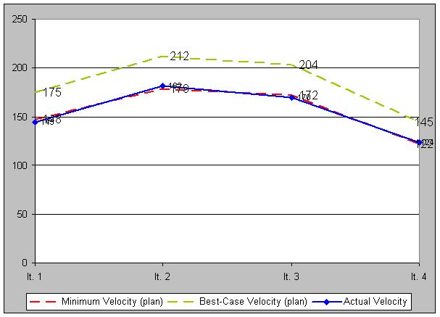

Burn up
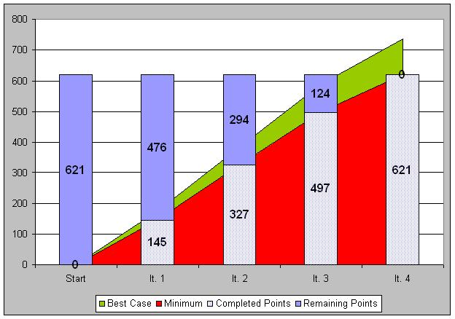

Team 2:
Current release: 1
Current iteration: 4

Velocity Chart
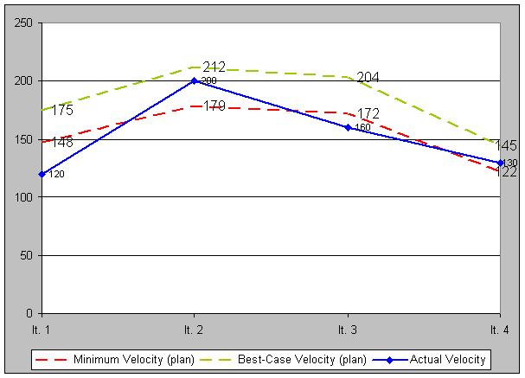

Burn up Chart
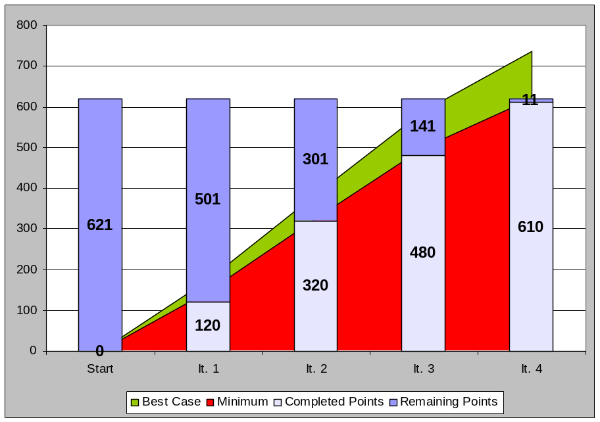

Team 3:
Current release: 1
Current iteration: 4

Project Velocity
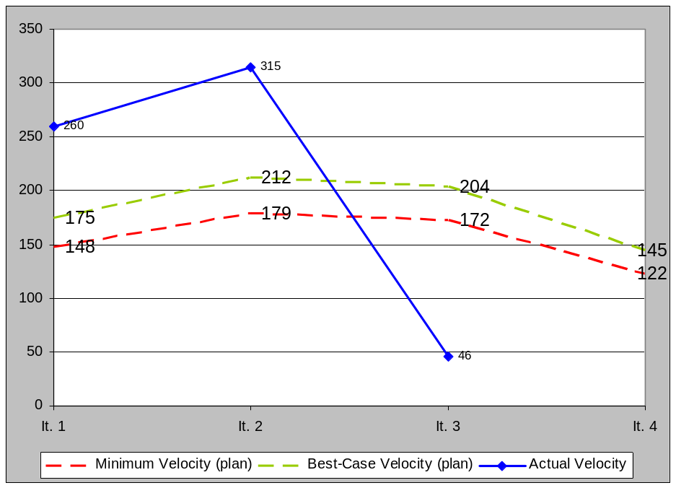

Release 4 Burn up
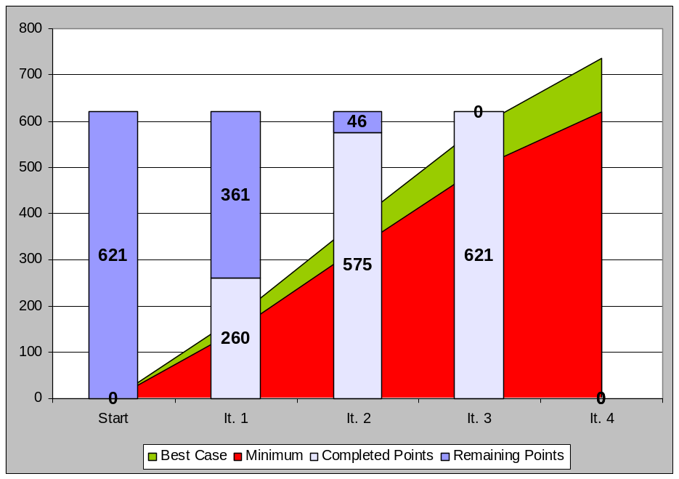

Team 4:
Current release: 1
Current iteration: 4

Project Velocity
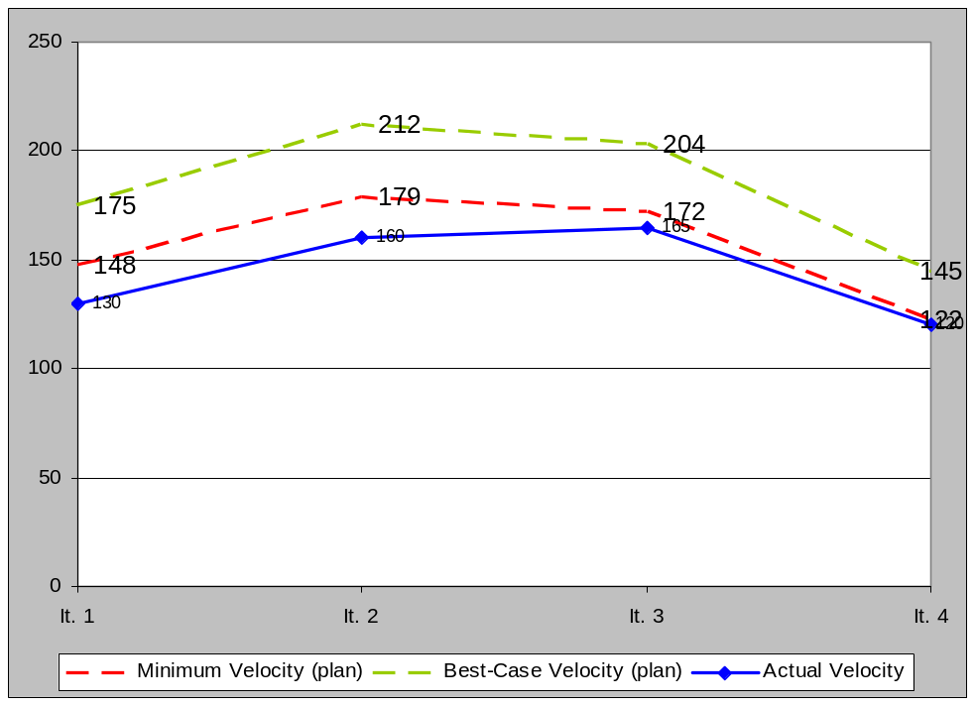

Project Burn up

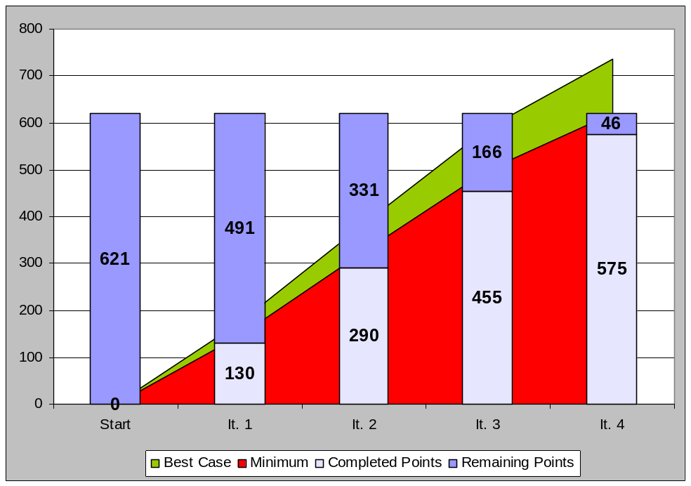

CASE STUDY: Bringing it all together

Read this handout carefully before you start the activity.

Background:
ABC Consulting is a small to mid-size consulting company that is growing at a rapid pace. Today, each ABC Consulting project manages their deliverables in isolation using a variety of document management tools such as VSS, local servers etc. As ABC Consulting grows and its global reach increases, the need for a common, centralized artifact management approach will become critical. Furthermore, ABC Consulting is interested in adopting an Agile methodology, that allows them to provide regular feedback regarding the direction of the product.
To address this need, Sapient will work with ABC Consulting to derive a solution for managing ABC Consulting project deliverables, similar in nature to earlier versions of ResultSpace (without the Plan tool feature), using Sapient’s Agile configuration of S|A. The solution is called the Collaborative Consulting Tool (CCT) and will encompass a common, centralized repository for managing, tracking and versioning project deliverables as well as discussion forums for knowledge exchange. Via the repository, and its cooperative tools and embedded security, ABC Consulting projects will be able to manage their project deliverables regardless of project location or mode of access.
To date, Sapient has conducted stand-alone workshops with ABC Consulting, without a full-blown Fusion workshop, and are about to start putting together a proposal that includes scope, price, HLP and a release plan. A couple of key decisions that came out of the Fusion include the following:
- The project start date will be Monday of next week
- The project must go live in 10 weeks after the project start date
- The iteration length will be 2 weeks, due to the short project duration, and the amount of involvement the client is demanding

Instructions:
Split into 2 (or 3) teams. The day will consist of 2 parts:
A. Artifact preparation
B. Role-plays

A. Artifact preparation (5 hours)
A variety of documents for the ABC Consulting CCT project already exist, that provide further background information. Read the following documents (located in the training folder):
- CCT Vision document
- CCT Use Case Model
- High level use case document
Furthermore, use the existing version of ResultSpace (without the Plan tool feature) as an example of the type of application that we are looking to build for ABC Consulting.

In your team, you have approximately 5 hours to prepare the artifacts below, assuming an Agile configuration of S|A. These artifacts will be used for the role-plays:
- Scope matrix
- Estimation tool
- Team structure
- High Level Plan
- Create the project overview on the ResultSpace project home page (including links to the Scope Matrix, Estimation tool etc)
- Release Plan in ResultSpace (an RS project per team has been created for this)
- Presentation for your team’s scenario role-play (see Scenario role-play below)

B. Role-plays (1 hour 15 min per team)
The role-play for each team will consist of 3 parts:
- Estimate Review role-play (45 min)
- Scenario role-play (15 min)
- Feedback (15 min)

(1) Estimate Review role-play
All teams: Role-play an Estimate Review that covers a review of the following:
- Project overview home page that includes links to the artifacts being reviewed
- Scope matrix
- Estimate
- Team structure
- High level plan
- Release plan
When one team presents their artifacts, the audience will role-play play the estimate reviewers, who will probe the team and thought process that has gone into the artifact development.

(2) Scenario role-play
Scenario 1: Role play the meeting with the client where the client expectations are set regarding how the project will be run using S|A, some of the key concepts (eg stories), what is expected of them and when
Scenario 2: Role-play the Iteration 1 kickoff (partial) that includes the story selection
Scenario 3: Role-play the end of iteration 2 checkpoint with the client, assuming that the iteration 2 kickoff has already happened and the iteration 2 plan was closed. (Tip: use ResultSpace as the CCT tool that the client can try out)
For each role-play, the team owning the scenario will play the Sapient team, the training facilitator will play the client Product Owner, and the rest of the audience will play other client SMEs.

